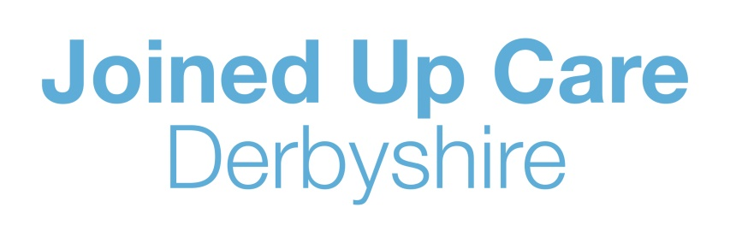
E: joinedupcarederbyshire@nhs.net
T: https://joinedupcarederbyshire.co.uk

Media information
9 September 2021

‘NOW MORE THAN EVER WE NEED EVERYONE’S HELP’ - HEALTH BOSSES URGE PUBLIC TO HELP THE LOCAL NHS

NHS and care services across Derbyshire are once again asking for the public’s help to make sure they can focus care on the sickest patients.

All health and care services across the city and county have felt the strain as life returns to normal following Covid-19 restrictions coming to an end but for health and care staff the challenge of the pandemic has not gone away and services are under severe pressure.

Alongside increases in hospital patients who have confirmed Covid-19 – 77 patients across three sites, an increase from 65 this time last week – with 11 being in the most critical condition, there has been a significant increase in poorly patients with other illnesses. At the same time, the A&E teams are seeing increasing numbers of patients, with 1,038 patients in just one day this Monday at Chesterfield Royal, Royal Derby Hospital and Queen's Hospital, Burton.

As a result of A&E being full, patients are experiencing long waits. This also means ambulances need to wait longer outside of A&E before their crews can pass on the care of patients. For patients nearing discharge, adult care and community services are also very busy, which means patients can’t be discharged quickly once they are medically fit. This means hospital beds are filling to capacity.

Brigid Stacey, Chief Nursing Officer for NHS Derby and Derbyshire Clinical Commissioning Group (CCG), said: “All our staff working in health and care services are trying to make sure we see people who need us."

“Pressure is on every part of the health and care system from our GPs working tirelessly to return every call to a patient in need, to beds being limited in care homes due to staffing shortages and outbreaks of illnesses. As always we are working together as a system to do everything we can to make sure we get the care to everyone who needs it. We need the public to help us and this might include helping us when patients are ready for discharge from hospital."

With hospitals full and patients waiting for long periods of time, the clinical teams are doing all they can to make sure people in hospital who are well are able to return home. The hospital teams rely on families to help with getting their loved ones home, and that help is needed now more than ever.

Berenice Groves, Chief Operating Officer at Chesterfield Royal Hospital, said: “We want to offer the best care to all of our patients whether it’s via A&E so they get the urgent care they need or a specialist team to treat cancer or other urgent conditions.

“We're having to redeploy staff from our operating theatres to work in critical care units, which unfortunately means we need to cancel some operations. If you're called with a cancellation then we know this will be disappointing. Please be assured we are only doing this where necessary and feel we have little alternative. Please try to be understanding when our staff call."

"Families can also really help us by supporting their loved ones to go home whilst they await a care package or accept a placement in a care home. We know this is not ideal and we are grateful to families for continuing to do everything they can to support loved ones to return home so we can get patients who really do need to be in hospital into a bed quicker."

"We are also having to take extra steps to discharge patients to the first available residential or nursing home bed, which in some cases may not be the bed closest to the patient's home. We would appreciate families' support with this to help us ensure we can prioritise hospital treatment for those patients who are the most poorly."
Dr Magnus Harrison, medical director at University Hospitals of Derby and Burton NHS Foundation Trust, said: “We are here for patients who have a major, life changing or life threatening illness. Colleagues at Urgent Treatment Centres and NHS 111 online can provide advice for other illness or injury. Please also, where possible, make your own way to hospital where this is safe rather than relying on an ambulance via 999.

“People turning up at hospitals with minor illnesses are waiting a very long time for treatment. We have seen people who have attended A&E with coughs and colds, which can be easily treated by a pharmacist or at home. For more advice and guidance, visit 111.co.uk who can direct you to the most appropriate service.”

“We are asking people to use the most appropriate services available to them for anything that is not life threatening and if you are unsure visit 111 online. GPs are open and pharmacies can help with advice and give many over the counter solutions to colds, tummy troubles and rashes. Our urgent treatment centres are a good alternative to A&E if your injury is not life-threatening. They can treat you for serious conditions such as minor head bumps and suspected broken bones.”

Brigid Stacey added, “We have been so grateful for the public support throughout the pandemic. We have been overwhelmed by kindness and thoughtful gestures. We know the public are incredible in their support and the biggest thing they can do now to help us, is to think about how they use our services, to help us to help you. Our local GPs, urgent treatment centres and pharmacists are incredible and offer excellent treatment. There are evening appointments available and the waits are much shorter for minor ailments.

“We don’t want people to wait and we want to offer the best care we can, but saving lives is the main job of A&E and we must always prioritise life.”

"And we also need support from families in helping to discharge patients when they are ready and to accept that they may not necessarily go to the care home you’d normally choose."

Background

Remember

The NHS is here for you and so if you are concerned about a new lump or mole or have any other health issues then please get in touch with your GP.
If it is not an emergency you can use a range of service, such as:
Pharmacy

Pharmacies can offer over the counter advice and treat common illnesses such as colds, sore throats, stings and allergies.
Call 111 First

Once a patients calls 111 or visits 111 online they will be navigated to the most appropriate service, first time by a trained operator. The operator will even be able to book appointments and timeslots at the most appropriate health service for your needs.

Visit the NHS Urgent Care Centre

Urgent Treatment Centre
Whitworth Hospital | 8am-8pm, every day
Buxton Hospital | 8am-8pm, every day
Ripley Hospital | 8am-8pm, every day
Ilkeston Hospital | 8am-8pm, every day
Derby Urgent Treatment Centre | 8am-8pm, every day

ENDS

NOTES TO EDITORS:
For further information please call Sean Thornton on 07920 024641.

Joined Up Care Derbyshire is made up of the following partners:

The organisation that commissions health services:
NHS Derby and Derbyshire Clinical Commissioning Group

Organisations that provide healthcare services:
Chesterfield Royal Hospital
Derbyshire Community Health Care Services
Derbyshire GP Alliance
Derbyshire Healthcare
DHU Healthcare
East Midlands Ambulance Service
University Hospitals of Derby and Burton
Organisations that provide and commission and provide public services and social care:
Derby City Council
Derbyshire County Council

More information on Joined Up Care Derbyshire is available at:

Web: www.joinedupcarederbyshire.org.uk
Twitter: @joinedupcare
Facebook: Joined Up Care Derbyshire
Instagram: @joinedupcarederbyshire

